Bigtreetech SKR mini V2.0 - install BLTouch and Smart sensor

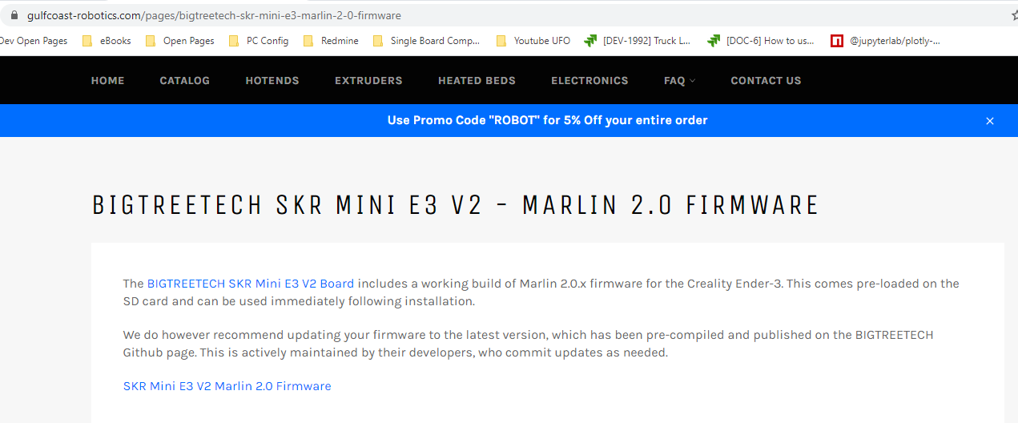

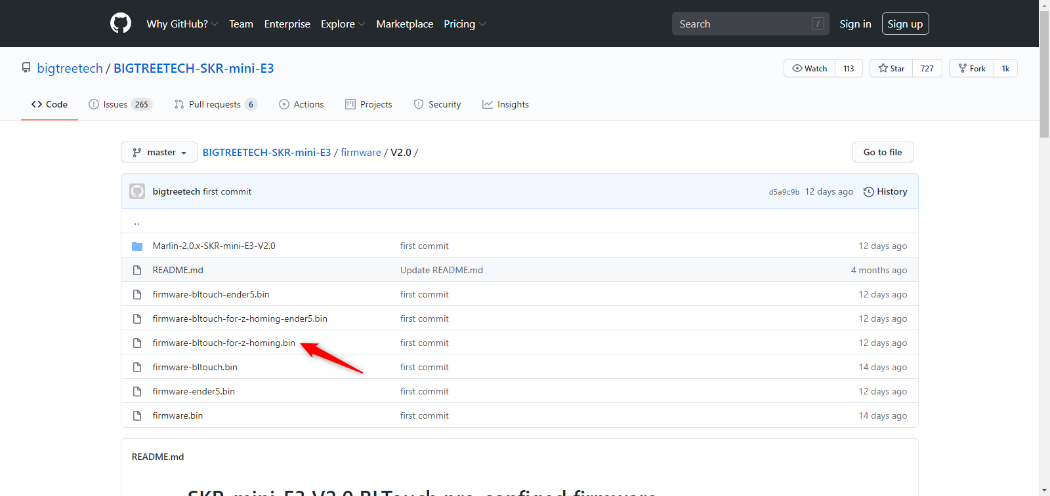

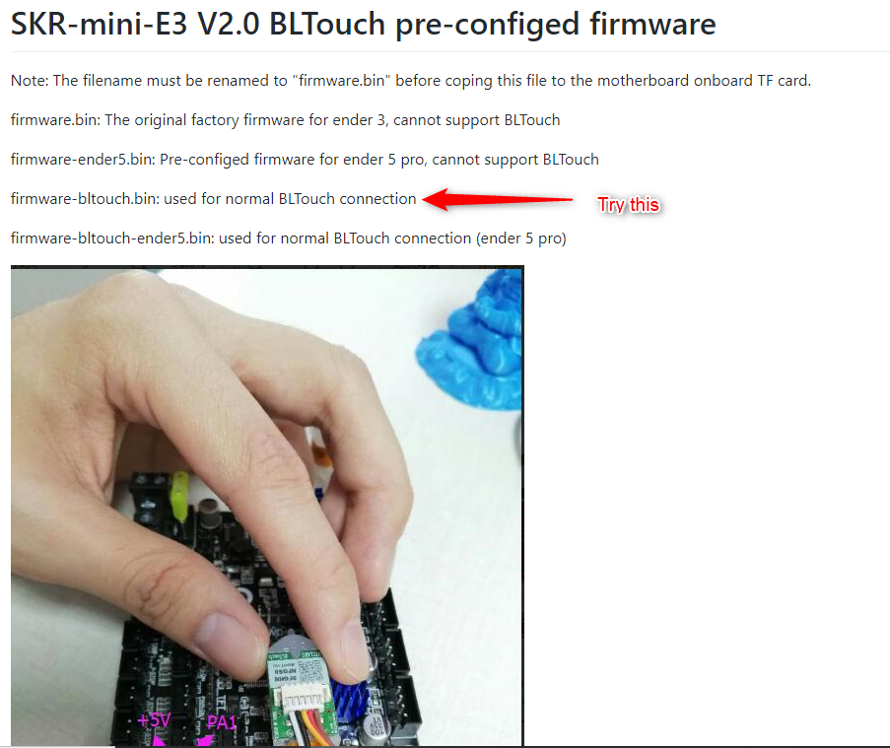

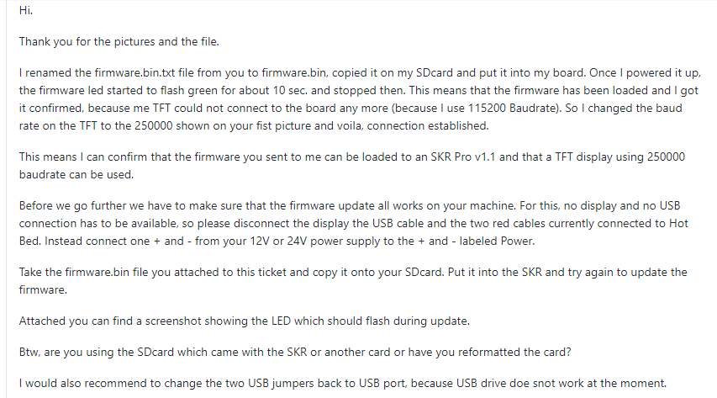

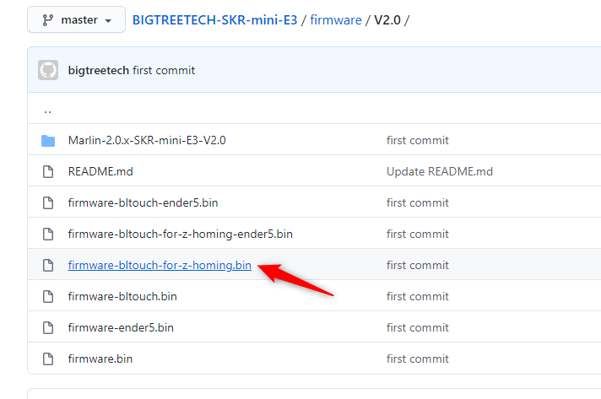

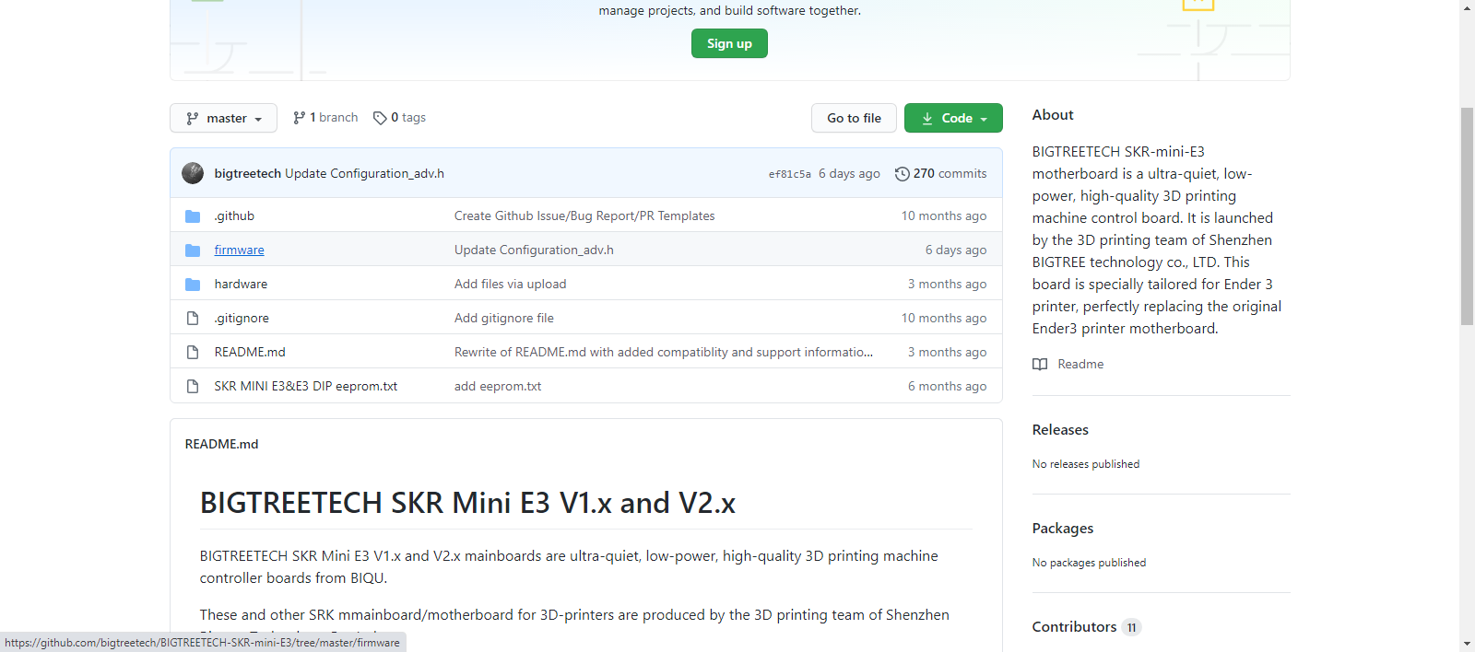

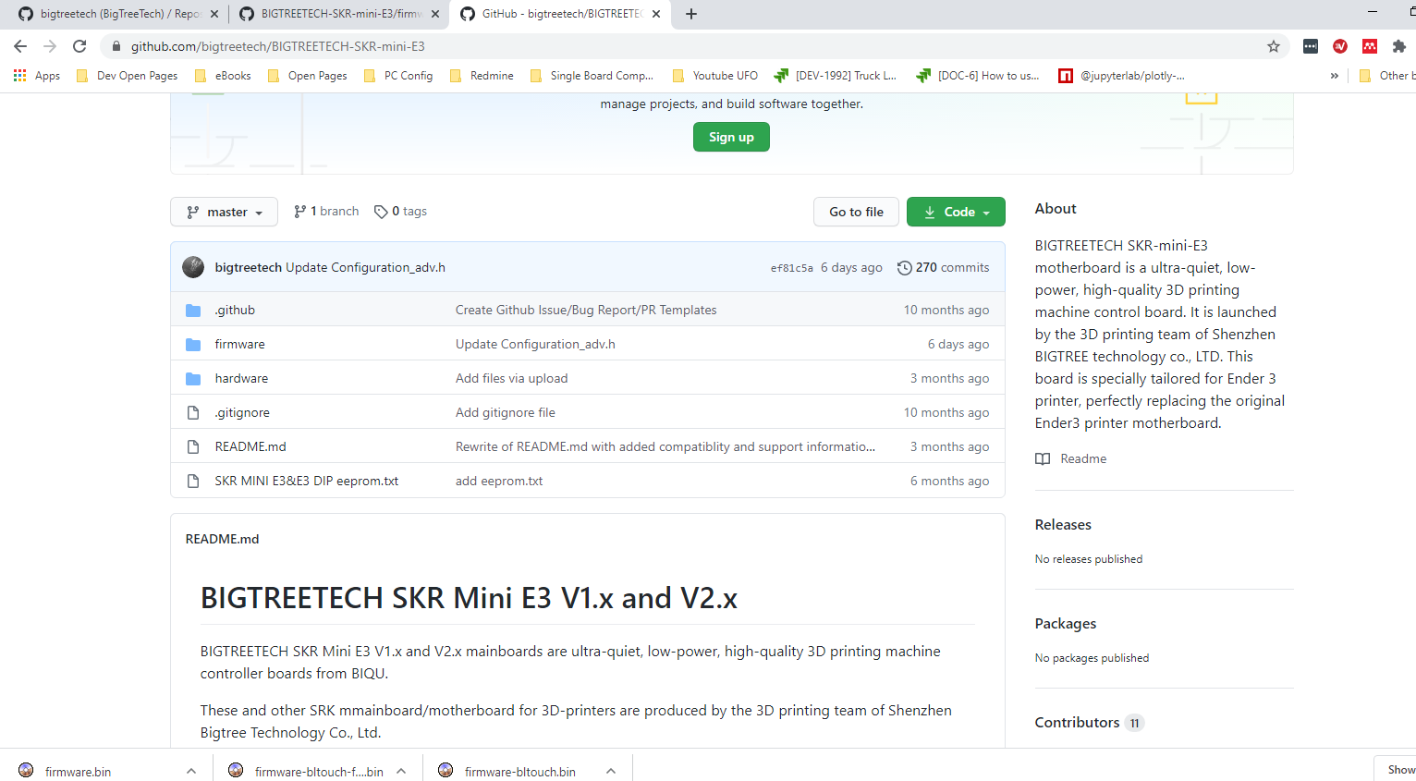



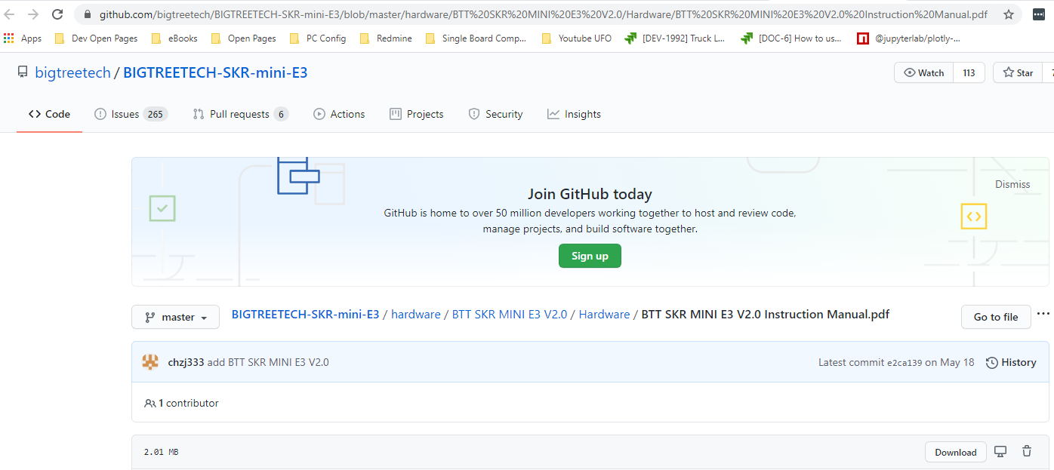

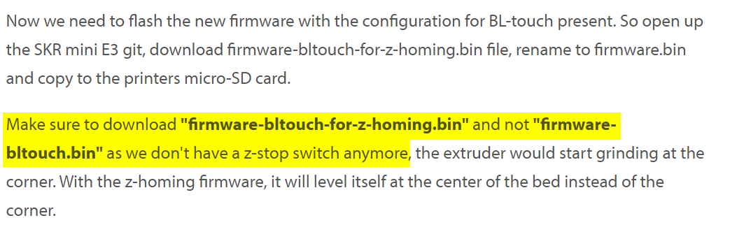

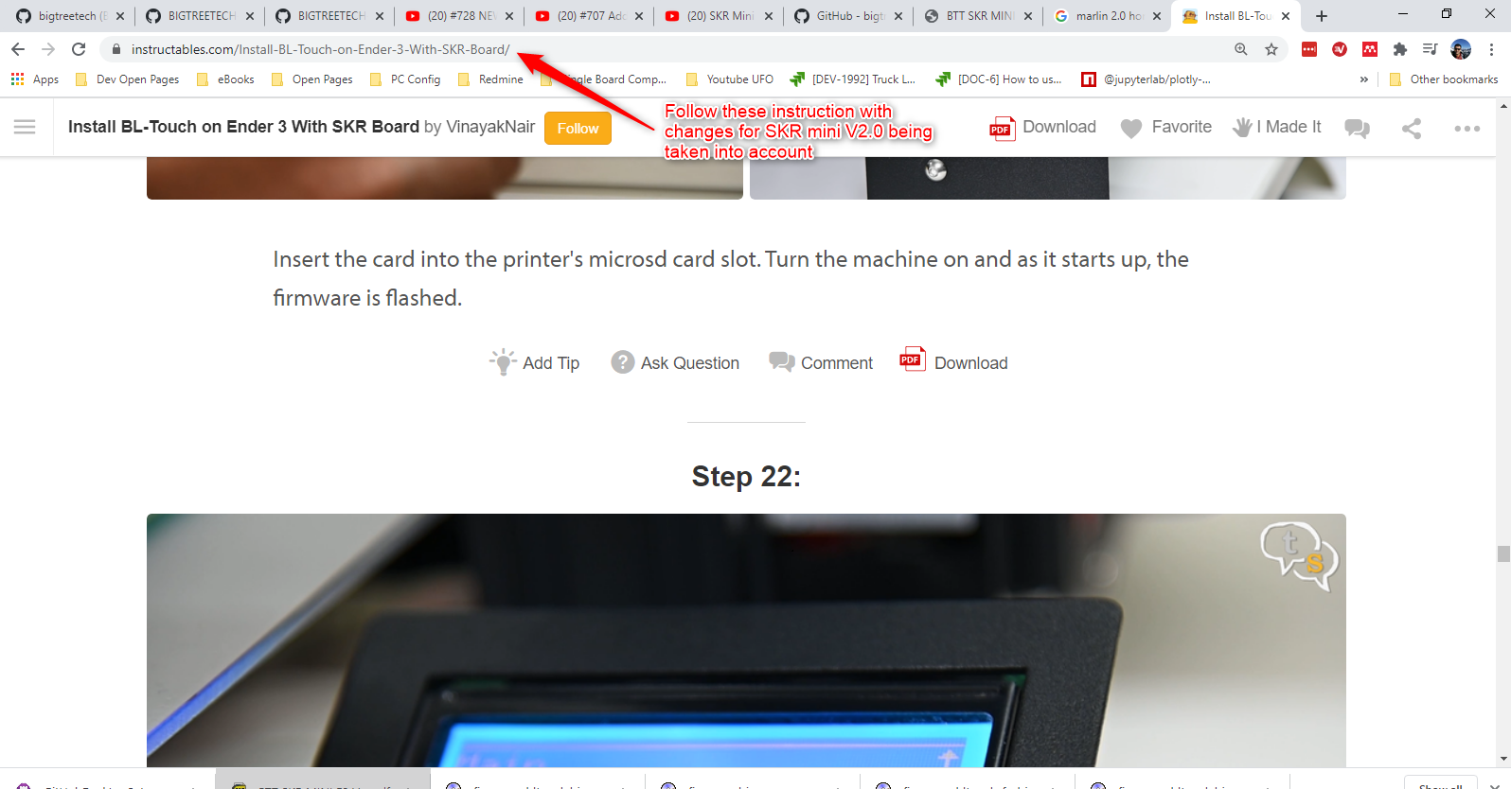

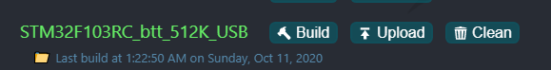



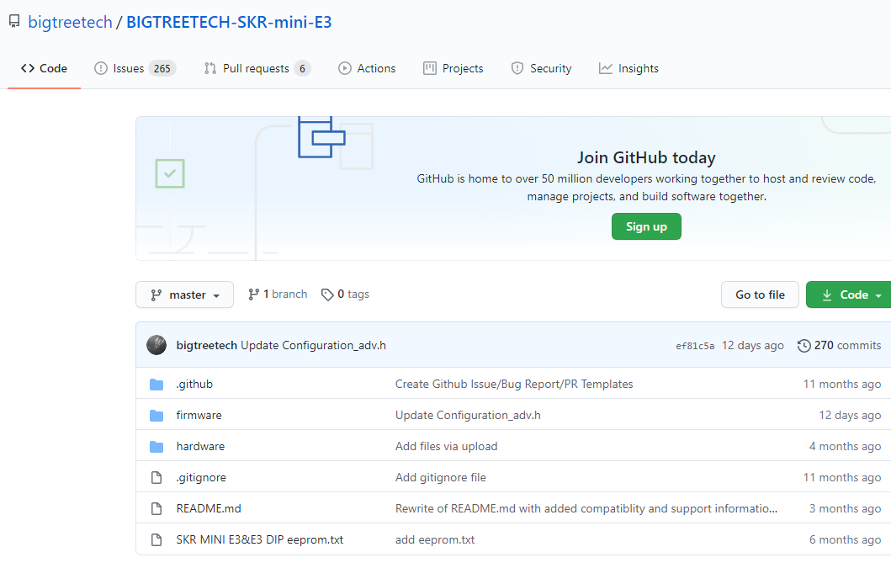

# Try #2: From GitHub code SKR mini V2.0, add BLtouch, add Smart Filament Sensor

SKR Board: BigTreetech-SKR-mini-E3-V2.0

Install Marlin 2.0.7.2-skr-mini-e3-v2.0

Firmware URL: <https://github.com/bigtreetech/BIGTREETECH-SKR-mini-E3/tree/master/firmware/V2.0/Marlin-2.0.7.2-SKR-mini-E3-V2.0>

Root Git: <https://github.com/bigtreetech/BIGTREETECH-SKR-mini-E3.git>

## Fork SKR mini E3 repo

General instructions here for reference only: <https://docs.github.com/en/free-pro-team@latest/github/getting-started-with-github/fork-a-repo>

Requirements:

1. Have a Github account

In Browser, login to your GitHub account

Go to the following project in GitHub: <https://github.com/bigtreetech/BIGTREETECH-SKR-mini-E3.git>

On top right hand side of the github page, click on “Fork”. This will create a fork of the project in your Github account.

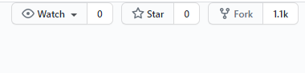

Install GitHub Desktop and connect it to your GitHub account

With GitHub desktop, Go to Menu File -> Clone repo

Select from GitHub.com, repo “BigTreeTech-SKR-mini-E3”. Click Clone button

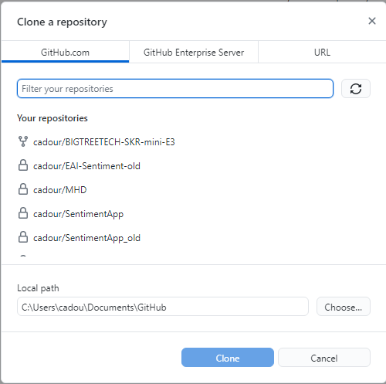

We will now compile the project under

C:\Users\cadou\Documents\GitHub\BIGTREETECH-SKR-mini-E3\firmware\V2.0

## Compile Code:

Start Visual Code

Install needed extensions:

1. Auto build Marlin 2.x
2. C/C++
3. PlatformIO IDE 2.2.1

More details here:

|  |
| --- |
| ## Building Marlin 2.0  To build Marlin 2.0 you'll need [Arduino IDE 1.8.8 or newer](https://www.arduino.cc/en/main/software) or [PlatformIO](http://docs.platformio.org/en/latest/ide.html#platformio-ide). Detailed build and install instructions are posted at:  - [Installing Marlin (Arduino)](http://marlinfw.org/docs/basics/install_arduino.html)  - [Installing Marlin (VSCode)](http://marlinfw.org/docs/basics/install_platformio_vscode.html). |

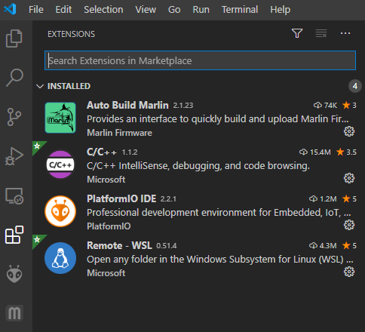

File 🡪 Open Folder: C:\Users\cadou\Documents\GitHub\BIGTREETECH-SKR-mini-E3\firmware\V2.0\Marlin-2.0.7.2-SKR-mini-E3-V2.0

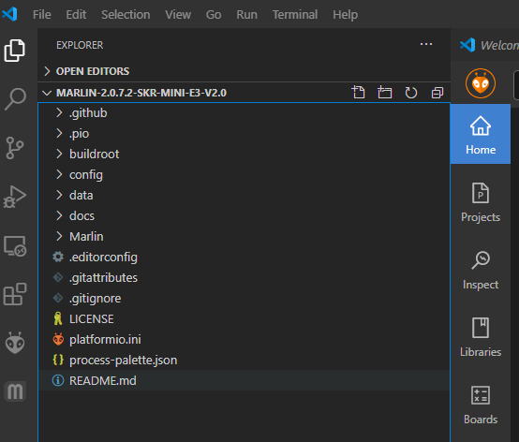

Click on AutoBuid Marlin button on Middle Left tab: 

Click on the hammer in the menu that appears

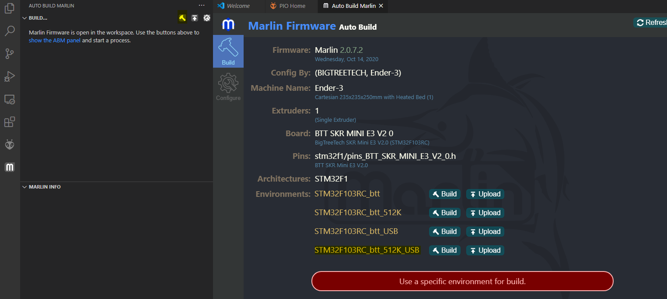

Select “STM32F103C_btt_512K_USB” and Build

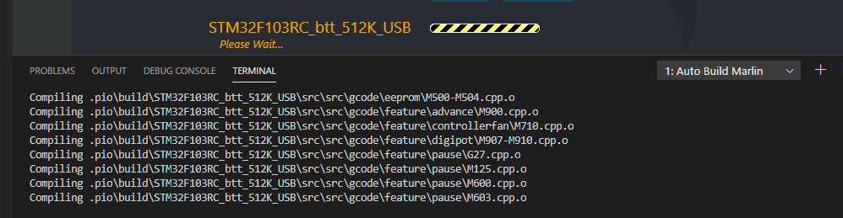

## Phase 1: Install the default firmware on the Ender3 with the SKR board

After the compilation is over, locate the firmware.bin binary at following location:

C:\Users\cadou\Documents\GitHub\BIGTREETECH-SKR-mini-E3\firmware\V2.0\Marlin-2.0.7.2-SKR-mini-E3-V2.0\.pio\build\STM32F103RC_btt_512K_USB

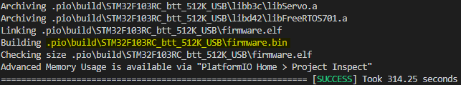

Remove the SDcard from the Ender3 SKR board and mount it on the computer with an SD card to USB connector.

Copy the firmware.bin to the SD Card root folder.

Experimental results: Default Marlin 2.0.7.2 loading on Ender 3 but no User interface showing.

Compilation results

|  |  |  |
| --- | --- | --- |
| **Version** | **Build** | **Results** |
| Marlin 2.0.7.2-SKR-mini-E3-V2.0 | STM32F103RC_btt_512K_USB | Ender 3 UI is empty, nothing is displayed on the screen. |
|  |  |  |

~~Find process for builing Markin 2.0x for SKR mini-E3-V2.0 using the BigTreeTech repo~~

~~Marlin configs:~~

[~~https://github.com/MarlinFirmware/Configurations/tree/release-2.0.7.2~~](https://github.com/MarlinFirmware/Configurations/tree/release-2.0.7.2)

~~Downloaded these files:~~ [~~https://github.com/MarlinFirmware/Configurations/tree/release-2.0.7.2~~](https://github.com/MarlinFirmware/Configurations/tree/release-2.0.7.2)

~~Specifically, the config files for Marlin 2.0.7.2 from~~

[~~https://github.com/MarlinFirmware/Configurations/tree/release-2.0.7.2/config/examples/Creality/Ender-3/BigTreeTech%20SKR%20Mini%20E3%202.0~~](https://github.com/MarlinFirmware/Configurations/tree/release-2.0.7.2/config/examples/Creality/Ender-3/BigTreeTech%20SKR%20Mini%20E3%202.0)

~~Copy the following files:~~

|  |  |
| --- | --- |
| ~~From~~ | ~~To~~ |
| [~~https://github.com/MarlinFirmware/Configurations/tree/release-2.0.7.2/config/examples/Creality/Ender-3/BigTreeTech%20SKR%20Mini%20E3%202.0~~](https://github.com/MarlinFirmware/Configurations/tree/release-2.0.7.2/config/examples/Creality/Ender-3/BigTreeTech%20SKR%20Mini%20E3%202.0) | ~~Folder: XYZ\firmware\V2.0\Marlin-2.0.7.2-SKR-mini-E3-V2.0\Marlin~~  ~~Full path: C:\Users\cadou\Documents\GitHub\BIGTREETECH-SKR-mini-E3\firmware\V2.0\Marlin-2.0.7.2-SKR-mini-E3-V2.0\Marlin~~ |

~~Build and test~~

* ~~This combination of Marlin 2.0.7.2 with config files for Marlin 2.0.7.2/Ender 3/SKR Mini E3 V2.0 produces EXPECTED RESULTS.~~

## Phase 2: Configure the firmware for the BLTouch, recompile and test on the Ender 3

|  |
| --- |
| **#Modify Configuration.h**  #define BLTOUCH  #define GRID_MAX_POINTS_X 3  #define Z_SAFE_HOMING  **## try #1: tested these changes 🡪 LCD screen is blank**  #define AUTO_BED_LEVELING_BILINEAR  #define LCD_BED_LEVELING  #define LEVEL_BED_CORNERS  //#define LCD_FEEDBACK_FREQUENCY_DURATION_MS 20  //#define LCD_FEEDBACK_FREQUENCY_HZ 1000 |
| **## try #2:**  #define AUTO_BED_LEVELING_BILINEAR  //#define LCD_BED_LEVELING  //#define LEVEL_BED_CORNERS  //#define LCD_FEEDBACK_FREQUENCY_DURATION_MS 20  //#define LCD_FEEDBACK_FREQUENCY_HZ 1000   * Working |
|  |
| # Modify Configuration_adv.h  #define BLTOUCH_DELAY 500  #define BLTOUCH_FORCE_SW_MODE |
|  |
| # Compile for environment: STM32F103RC_btt_512K_USB |

Complete instructions for SKR Mini E3 v2.0 and BLTouch: <https://www.youtube.com/watch?v=1NhAo3xR9HY>

Includes firmware configuration: <https://www.antclabs.com/bltouch-v3>

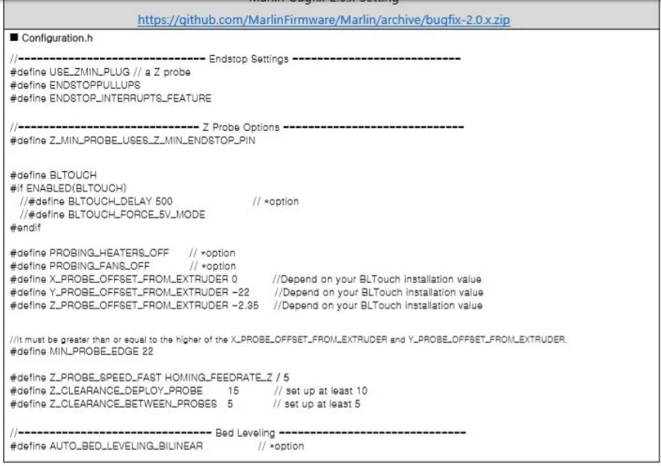

Instructions to adjust the bltouch position/height:

1. <https://www.youtube.com/watch?v=7le9L2LMY-U>

~~Instructions:~~

1. [~~https://www.youtube.com/watch?v=dRgWrepDUBE~~](https://www.youtube.com/watch?v=dRgWrepDUBE)
2. [~~https://www.youtube.com/watch?v=VQ5-Wd1mM4Q&t=2687s~~](https://www.youtube.com/watch?v=VQ5-Wd1mM4Q&t=2687s)

~~Bootloader / Marlin flashing guide -~~ [~~https://github.com/3d-printing-canada/Ender-3-BL-Touch-Installation~~](https://github.com/3d-printing-canada/Ender-3-BL-Touch-Installation)

~~Getting the reference config files from:~~

[~~https://github.com/3d-printing-canada/Ender-3-BL-Touch-Installation/tree/master/Marlin%202.0%20-%20Ender%203%20BL%20Touch/config/examples/Creality/Ender-3~~](https://github.com/3d-printing-canada/Ender-3-BL-Touch-Installation/tree/master/Marlin%202.0%20-%20Ender%203%20BL%20Touch/config/examples/Creality/Ender-3)

~~Compare them to SKR config files and determine changes required to enable BLTouch~~

~~Changes to config files described here:~~

[~~https://3dwork.io/en/configure-bltouch-in-marlin/~~](https://3dwork.io/en/configure-bltouch-in-marlin/)

## Phase 3: Configure the firmware for the Bigtreetech Smart filament sensor, recompile and test on the Ender3

Instructions at:

<https://github.com/bigtreetech/smart-filament-detection-module/tree/master/manual>

In manual: [smart filament sensor module manual191205.pdf](https://github.com/bigtreetech/smart-filament-detection-module/blob/master/manual/smart%20filament%20sensor%20module%20manual191205.pdf)

When the bed and extruder are heated and the printer is about to start Homing, it starts making a whining sound (motor changing speed or something) and reboots.

Changes from previous config of the BLTouch are as follows however the system is rebooting when Auto-Home is called.

Uncomment:

Uncomment:

1. #define FILAMENT_RUNOUT_SENSOR
2. #define FILAMENT_RUNOUT_DISTANCE_MM
3. #define FILAMENT_MOTION_SENSOR

